**Assignment 3 : Retrieve data using Group By clause**

**--------------------------------------------------------------------------------------------------------------------------**

**Sample table1:Department**

**-dept_id**

**-dept_name**

**Sample table2: Employee**

**-emp_id**

**-dept_id**

**-mngr_id**

**-emp_name**

**-salary**

CREATE TABLE [DEPARTMENT]

( dept_id INT PRIMARY KEY IDENTITY(1001,1),

dept_name VARCHAR(50) NOT NULL

)

INSERT INTO [DEPARTMENT] VALUES ( 'FINANCE') ,('AUDIT'),('MARKETING'),('PRODUCTION')

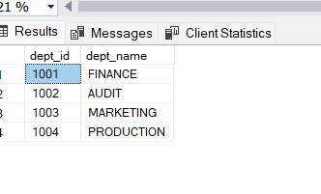

CREATE TABLE [EMPLOYEE]

(emp_id INT PRIMARY KEY IDENTITY(2001,1),

dept_id INT NOT NULL,

mngr_id INT,

emp_name NVARCHAR (50) NOT NULL,

salary INT NOT NULL

)

INSERT INTO [EMPLOYEE] VALUES (1001,NULL,'KAYLING',55000),(1003,6001,'BLAZE',50000),(1001,6002,'CLARE',42000),(1002,6003,'JONAS',48000),(1002,6004,'SCARLET',51400),(1002,6005,'FRANK',53000),(1002,6006,'SANDRINE',50500),(1003,6007,' ADELYN ',48507)

SELECT * FROM [EMPLOYEE]

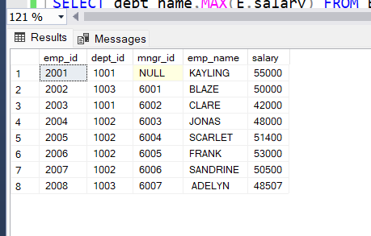

**1. write a SQL query to find Employees who have the biggest salary in their Department**

SELECT E.emp_name,E.salary ,D.dept_name FROM Employee E JOIN Department D ON E.dept_id=D.dept_id

WHERE E.salary IN (select MAX(salary) from Employee group BY dept_id HAVING D.dept_id=Employee.dept_id) or E.salary is null

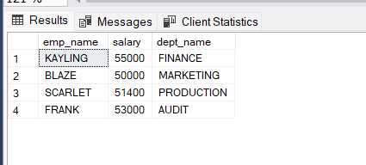

**2. write a SQL query to find Departments that have less than 3 people in it**

SELECT dept_name,COUNT(E.emp_name) FROM EMPLOYEE E RIGHT JOIN DEPARTMENT D ON E.dept_id=D.dept_id GROUP BY D.dept_name HAVING COUNT(E.emp_name )<3

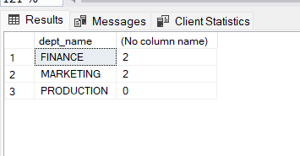

**3. write a SQL query to find All Department along with the number of people there**

SELECT dept_name,COUNT(E.emp_name) AS COUNTOFEMPLOYEE FROM EMPLOYEE E RIGHT JOIN DEPARTMENT D ON E.dept_id=D.dept_id GROUP BY D.dept_name

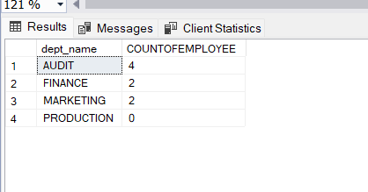

**4. write a SQL query to find All Department along with the total salary there**

SELECT dept_name,SUM(salary) AS SALARYOFDEPARTMENT FROM EMPLOYEE E RIGHT JOIN DEPARTMENT D ON E.dept_id=D.dept_id GROUP BY D.dept_name

